ZAIN-UL-ABIDEEN

REG# 450682

Contents

1.1 Hard exercise python heckerrank 2

1.2 Medium exercise python heckerrank 2

1.1.1 Maximize it! 2

1.1.2 Validating Postal Codes. 3

1.1.3 Matrix Script. 3

1.2.1 Write a function. 4

1.2.2 The Minion Game. 5

1.2.3 Merge the Tools! 5

1.2.4 Time Delta. 6

1.2.5 Find the Angle MBC. 7

1.2.6 No Idea! 7

1.2.7 Word order. 8

1.2.8 Compress the string. 8

1.2.9 Company logo. 9

1.2.10 Piling Up 9

1.2.11 Triangle Quest 2. 10

1.2.12 Iterables & iterators 10

1.2.13 Triangle Quest 10

1.2.14 Classes: Dealing with Complex Numbers. 11

1.2.15 Athlete Sort. 12

1.2.16 ginortS. 12

1.2.17 Validating Email Addresses With a Filter. 13

1.2.18 Reduce Function. 14

1.2.19 Regex Substitution. 14

15

1.2.20 Validating Credit Card Numbers. 15

1.2.21 Word Score. 15

1.2.22 Default Arguments. 16

# Hard exercise python heckerrank

# Medium exercise python heckerrank

## Maximize it!

1. from itertools import product
2. k, m = list(map(int, input().split()))
3. #print(k, m)
4. lines = []
5. for item in range(k):
6. lines.append(list(map(int, input().split()))[1:])
8. #print(lines)
9. result_list = list(product(*lines))
10. #print(result_list)
11. result = []
12. for tup in result_list:
13. total = 0
14. for item in tup:
15. total = total + (item**2)
17. result.append(total%m)
19. print(max(result))

## 1.1.2 Validating Postal Codes.

regex_integer_in_range = r"^[1-9][\d]{5}$"  # Do not delete 'r'.

regex_alternating_repetitive_digit_pair = r"(\d)(?=\d\1)"   # Do not delete 'r'.

import re

P = input()

print (bool(re.match(regex_integer_in_range, P))

and len(re.findall(regex_alternating_repetitive_digit_pair, P)) < 2)

## 1.1.3 Matrix Script.

#!/bin/python3

import math

import os

import random

import re

import sys

first_multiple_input = input().rstrip().split()

n = int(first_multiple_input[0])

m = int(first_multiple_input[1])

matrix = []

for _ in range(n):

    matrix_item = input()

    matrix.append(matrix_item)

decoded_list = list(zip(*matrix))

decoded_string = ''

for item in decoded_list:

    decoded_string = decoded_string + "".join(item)

print(re.sub(r'\b[^a-zA-Z0-9]+\b', r' ', decoded_string))

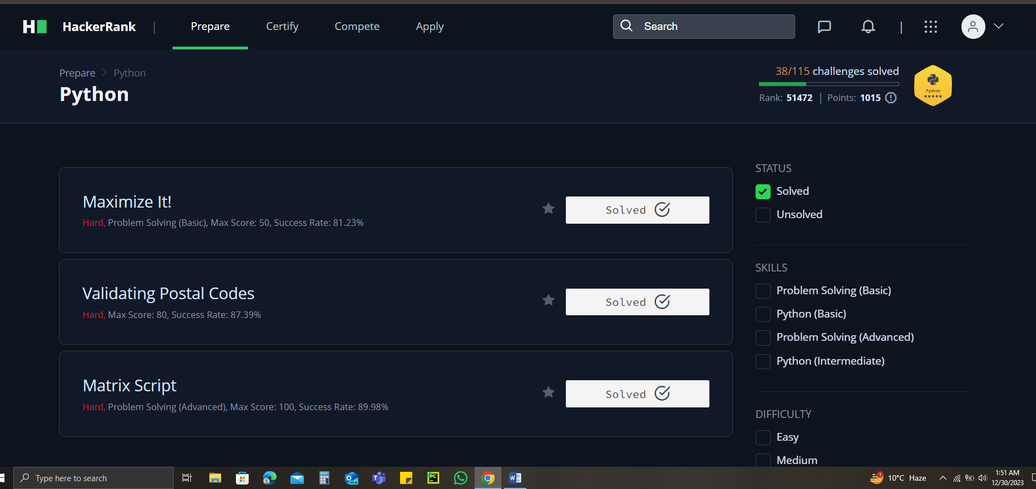

## Write a function.

1. def is_leap(year):
2. leap = False
4. if (year%4 ==0) and (year%100!=0 or year%400==0):
5. leap = True
7. return leap
8. year = int(input())
9. print(is_leap(year))
10. 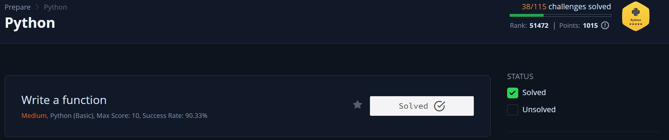

## 1.2.2 The Minion Game.

def minion_game(string):

   vowels = 'AEIOU'

   kevin_score = stuart_score =0

   length = len(string)

   for i in range(length):

       if string[i] in vowels:

           kevin_score += length -i

        else:

            stuart_score +=length -i

    if stuart_score > kevin_score:

        print(f'Stuart(stuart_score)')

    elif kevin_score > stuart_score:

        print(f'Kevin(kevin_score)')

    else:

        print('Draw')

if __name__ == '__main__':

    s = input()

    minion_game(s)

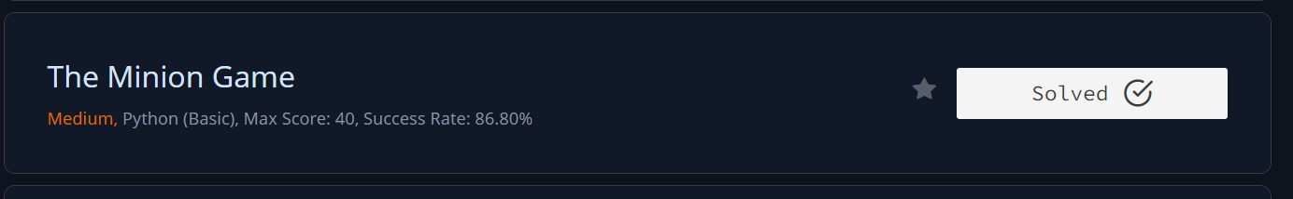

## 1.2.3 Merge the Tools!

def merge_the_tools(string, k):

    start = 0

    end = k

    while end<= len(string):

        temp = string[start:end]

        chunk = list(set(list(temp)))

        print(''.join(chunk))

        start += k

        end += k

if __name__ == '__main__':

    string, k = input(), int(input())

    merge_the_tools(string, k)

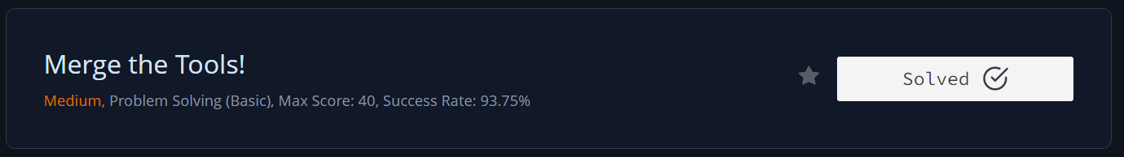

## 1.2.4 Time Delta.

from datetime import datetime

def time_delta(t1, t2):

    # Define the format of the timestamps

    fmt = '%a %d %b %Y %H:%M:%S %z'

    # Convert timestamps to datetime objects

    dt1 = datetime.strptime(t1, fmt)

    dt2 = datetime.strptime(t2, fmt)

    # Calculate the time difference

    delta = abs(dt1 - dt2)

    return int(delta.total_seconds())

if __name__ == "__main__":

    # Read the number of test cases

    t = int(input().strip())

    for _ in range(t):

        # Read two timestamps

        timestamp1 = input().strip()

        timestamp2 = input().strip()

        # Calculate and print the time difference

        result = time_delta(timestamp1, timestamp2)

        print(result)

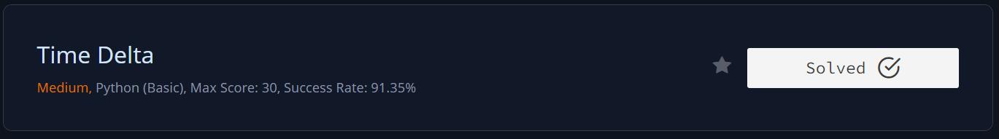

## 1.2.5 Find the Angle MBC.

import math

AB =int(input())

BC = int(input())

print(round(math.degrees(math.atan(AB/BC))),chr(176),sep='')

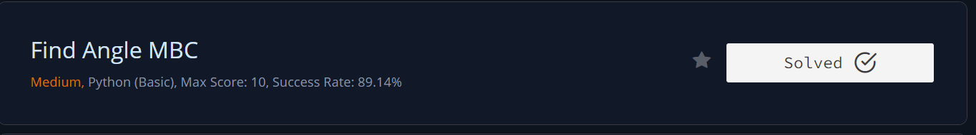

## 1.2.6 No Idea!

input()

n = input().split()

A = set(input().split())

B = set(input().split())

h = 0

for i in n:

    if i in A:

        h+= 1

    elif i in B:

        h-= 1

print(h)

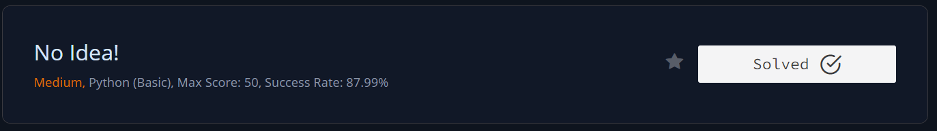

## 1.2.7 Word order.

from collections import OrderedDict

od = OrderedDict()

for i in range(int(input())):

    word = input()

    if word not in od:

        od[word] = 1

    else:

        od[word] += 1

print(len(od))

print(*od.values())

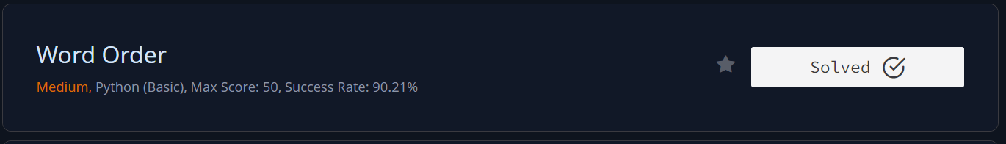

## 1.2.8 Compress the string.

s=input()

count = 1

for i in range(1, len(s)):

    if s[i]==s[i-1]:

        count +=1

    else:

        print((count, int(s[i-1])), end=" ")

        count=1

print((count, int(s[-1])))

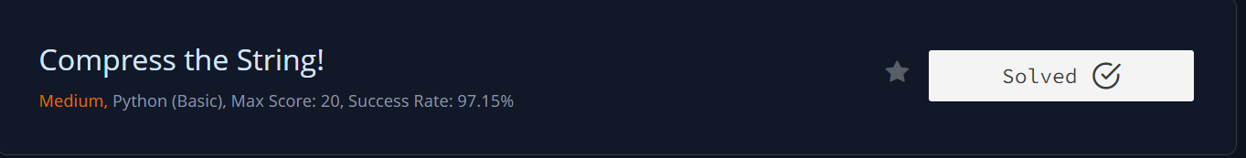

## 1.2.9 Company logo.

#!/bin/python3

import math

import os

import random

import re

import sys

from collections import Counter

if __name__ == '__main__':

    s = sorted(input())

    z= Counter(s)

   # print(z)

    z=Counter(s).most_common(3)

    # print(z)

    for x in z:

        print(*x)

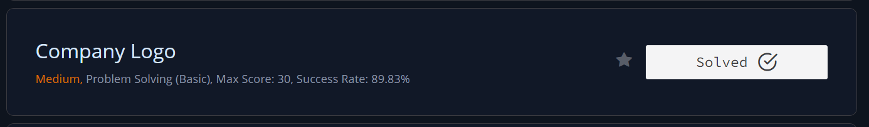

## 1.2.10 Piling Up

for t in range(int(input())):

    input()

    lst = [int(i) for i in input().split()]

    min_list = lst.index(min(lst))

    left = lst[:min_list]

    right = lst[min_list+1:]

    if left == sorted(left, reverse =True) and right == sorted(right):

        print("Yes")

    else:

        print("No")



## 1.2.11 Triangle Quest 2.

for i in range(1,int(input())+1): #More than 2 lines will result in 0 score. Do not leave a blank line also

    print (((10**i)//9)**2)



## 1.2.12 Iterables & iterators

# Enter your code here. Read input from STDIN. Print output to STDOUT

from itertools import combinations

n = int(input())

l = input().split()

k = int(input())

l1 = list(combinations(l, k))

counta = 0

for i in l1:

    if "a" in i:

        counta +=1

p = counta / len(l1)

print("%.4f"%p)

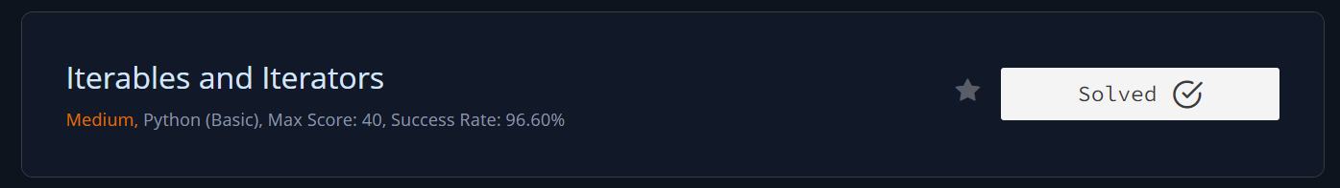

## 1.2.13 Triangle Quest

for i in range(1,int(input())): #More than 2 lines will result in 0 score. Do not leave a blank line also

    print(((10**i)//9)*i)



## 1.2.14 Classes: Dealing with Complex Numbers.

import math

class Complex(object):

    def __init__(self, real, imaginary):

        self.real = real

        self.imaginary = imaginary

    def __add__(self, no):

        return Complex(self.real+no.real, self.imaginary+no.imaginary)

    def __sub__(self, no):

        return Complex(self.real-no.real, self.imaginary-no.imaginary)

    def __mul__(self, no):

        r = self.real*no.real - self.imaginary*no.imaginary

        i = self.real*no.imaginary + self.imaginary*no.real

        return Complex(r, i)

    def __truediv__(self, no):

        d=no.real**2+no.imaginary**2

        n=self*Complex(no.real, -1*no.imaginary)

        return Complex(n.real/d, n.imaginary/d)

    def mod(self):

        d=self.real**2+self.imaginary**2

        return Complex(math.sqrt(d), 0)

    def __str__(self):

        if self.imaginary == 0:

            result = "%.2f+0.00i" % (self.real)

        elif self.real == 0:

            if self.imaginary >= 0:

                result = "0.00+%.2fi" % (self.imaginary)

            else:

                result = "0.00-%.2fi" % (abs(self.imaginary))

        elif self.imaginary > 0:

            result = "%.2f+%.2fi" % (self.real, self.imaginary)

        else:

            result = "%.2f-%.2fi" % (self.real, abs(self.imaginary))

        return result

if __name__ == '__main__':

    c = map(float, input().split())

    d = map(float, input().split())

    x = Complex(*c)

    y = Complex(*d)

    print(*map(str, [x+y, x-y, x*y, x/y, x.mod(), y.mod()]), sep='\n')

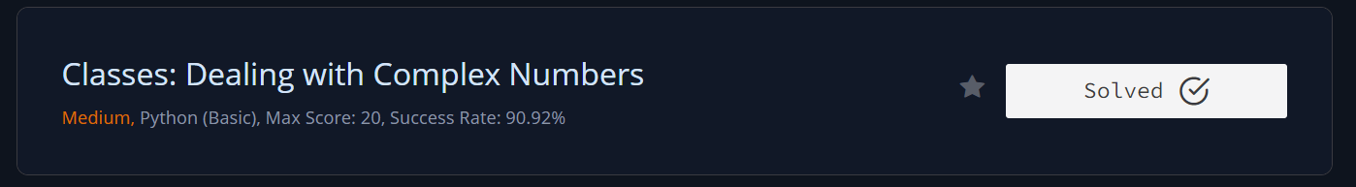

## 1.2.15 Athlete Sort.

from operator import itemgetter

nm = list(map(int,input().split()))

n, m = nm[0], nm[1]

row = []

for i in range(n):

    row += [list(map(int,input().split()))]

k = int(input())

arr = sorted (row, key=itemgetter(k))

for i in arr:

    print(*i)

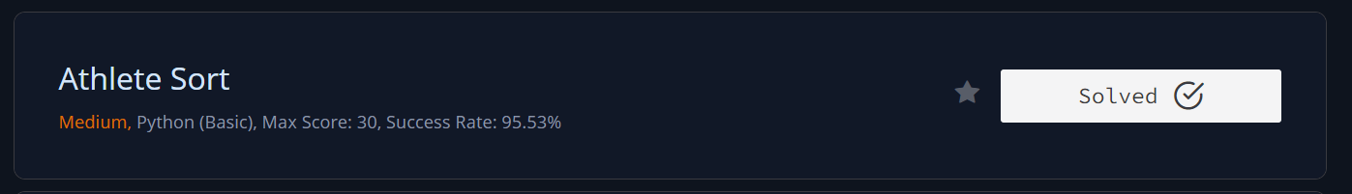

## 1.2.16 ginortS.

# lower, upper, odd , even

lower = ""

upper = ""

even = ""

odd = ""

s= sorted(input())

for i in s:

    if i.islower():

        lower += i

    elif i.isupper():

        upper+= i

    elif int(i) % 2 !=0:

        odd+= i

    elif int(i) % 2 == 0:

        even += i

print(lower+upper+odd+even)

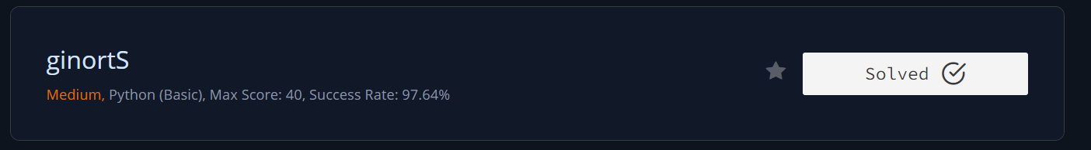

## 1.2.17 Validating Email Addresses With a Filter.

def fun(s):

    # return True if s is a valid email, else return False

    try:

        username, other = s.split("@")

        websitename, extension = other.split(".")

    except:

        return False

    username = username.replace("-", "").replace("_", "")

    if username.isalnum() == False:

        return False

    elif websitename.isalnum() == False:

        return False

    elif len(extension) > 3:

        return False

    else:

        return True

def filter_mail(emails):

    return list(filter(fun, emails))

if __name__ == '__main__':

    n = int(input())

    emails = []

    for _ in range(n):

        emails.append(input())

filtered_emails = filter_mail(emails)

filtered_emails.sort()

print(filtered_emails)

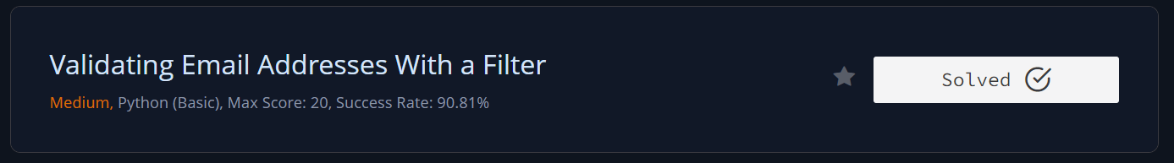

## 1.2.18 Reduce Function.

from fractions import Fraction

from functools import reduce

def product(fracs):

    t = reduce(lambda a, b : a*b, fracs)

    return t.numerator, t.denominator

if __name__ == '__main__':

    fracs = []

    for _ in range(int(input())):

        fracs.append(Fraction(*map(int, input().split())))

    result = product(fracs)

    print(*result)

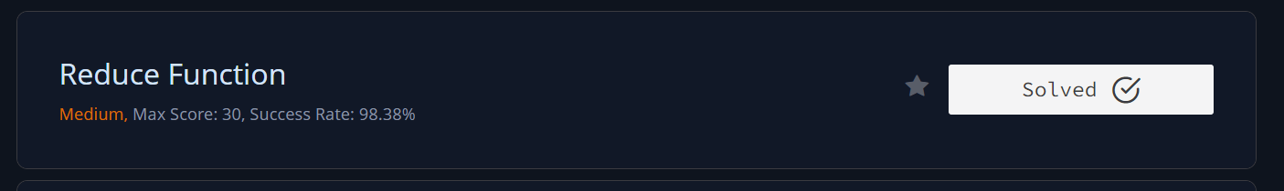

## 1.2.19 Regex Substitution.

import re

pattern = r"(?<= )(&&|\|\|)(?= )"

replacement = lambda x : "and" if x.group() == "&&" else "or"

for i in range (int(input())):

    s = input()

    print(re.sub(pattern, replacement, s))

## C:\Users\mega computers\OneDrive - National University of Sciences & Technology\Desktop\GIT-HUB PYTHON\regex subs.PNG

## 1.2.20 Validating Credit Card Numbers.

# Enter your code here. Read input from STDIN. Print output to STDOUT

import re

for _ in range(int(input())):

    S=input()

    t = re.search(r"^[456]\d{15}$|^[456]\d{3}-\d{4}-\d{4}-\d{4}$",S)

    if (t):

        if(re.search(r"(\d)\1{3,}|(\d)\2{1}-(\d)\2{1}|-(\d)\4{3}-", S)):

            print("Invalid")

        else:

            print("Valid")

    else:

        print("Invalid")

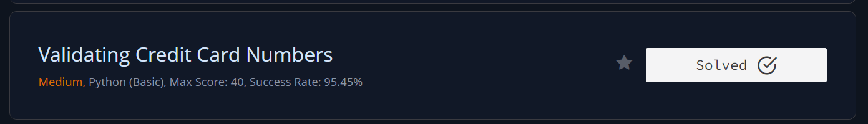

## 1.2.21 Word Score.

def is_vowel(letter):

    return letter in ['a', 'e', 'i', 'o', 'u', 'y']

def score_words(words):

    score = 0

    for word in words:

        num_vowels = 0

        for letter in word:

            if is_vowel(letter):

                num_vowels += 1

        if num_vowels % 2 == 0:

            score += 2

        else:

            score += 1

    return score

n = int(input())

words = input().split()

print(score_words(words))

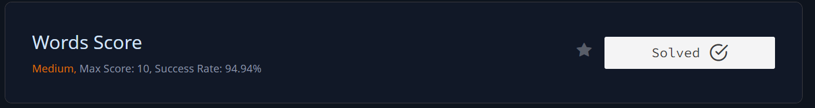

## 1.2.22 Default Arguments.

class EvenStream(object):

    def __init__(self):

        self.current = 0

    def get_next(self):

        to_return = self.current

        self.current += 2

        return to_return

class OddStream(object):

    def __init__(self):

        self.current = 1

    def get_next(self):

        to_return = self.current

        self.current += 2

        return to_return

def print_from_stream(n, stream=EvenStream()):

    stream.__init__()

    for _ in range(n):

        print(stream.get_next())

queries = int(input())

for _ in range(queries):

    stream_name, n = input().split()

    n = int(n)

    if stream_name == "even":

        print_from_stream(n)

    else:

        print_from_stream(n, OddStream())

